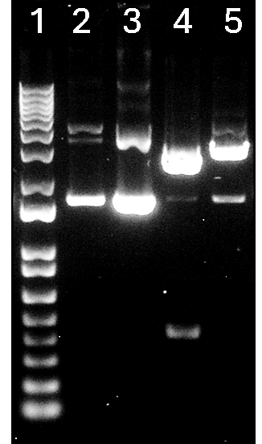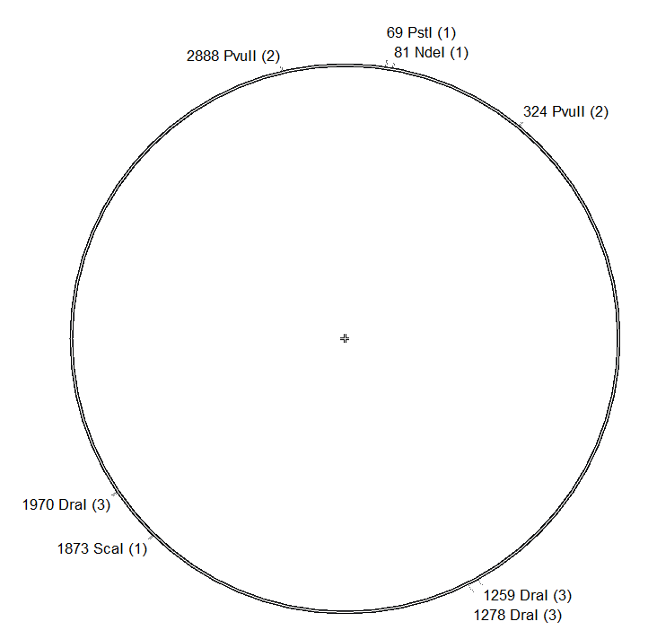
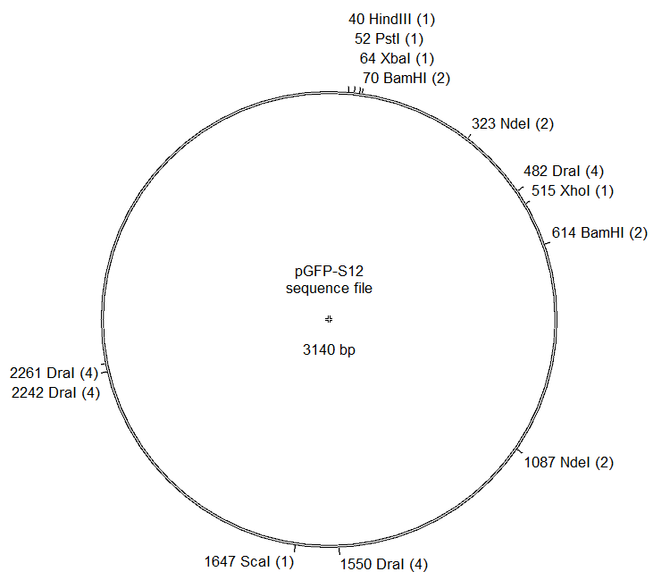
If unknown plasmid is pGFP-S12
2 - control | 3 - BamHI | 4 – Pvul1 | 5 - Ndel
1-4 bands | 2 cuts at bp 70, 614  = 2 bands of roughly 600bp and 2400bp | No digest- looks the same as control | 2 cuts at bp 324, 1088  = 2 bands of roughly 700bp and 2300bp
If unknown plasmid is pGEM-T
2 – control | 3 - BamHI | 4 – Pvul1 | 5 - Ndel
1-4 bands | No digest- looks the same as control | 2 cuts at bp 326, 2890  = 2 bands at roughly 2500bp, 500 bp | 1 cut at bp 82  = 1 band at 3000bp
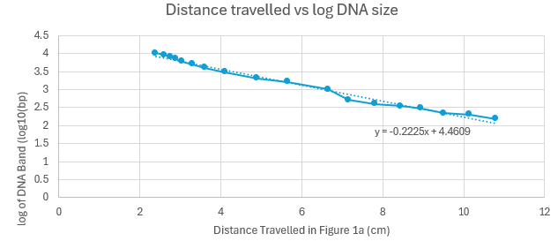
Ladder band | Distance travelled - center, cm |  |  | Invitrogen 1 Kb-Plus DNA ladder length (bp) |  |  |  | Log of DNA size
1 | 2.4 |  |  | 10180 |  |  |  | 4.007747778
2 | 2.6 |  |  | 9162 |  |  |  | 3.961990287
3 | 2.75 |  |  | 8144 |  |  |  | 3.910837765
4 | 2.9 |  |  | 7126 |  |  |  | 3.852845818
5 | 3.05 |  |  | 6108 |  |  |  | 3.785899028
6 | 3.3 |  |  | 5090 |  |  |  | 3.706717782
7 | 3.6 |  |  | 4072 |  |  |  | 3.609807769
8 | 4.1 |  |  | 3054 |  |  |  | 3.484869033
9 | 4.9 |  |  | 2036 |  |  |  | 3.308777774
10 | 5.65 |  |  | 1636 |  |  |  | 3.213783299
11 | 6.65 |  |  | 1018 |  |  |  | 3.007747778
12 | 7.15 |  |  | 511 |  |  |  | 2.7084209
13 | 7.8 |  |  | 396 |  |  |  | 2.597695186
14 | 8.45 |  |  | 344 |  |  |  | 2.536558443
15 | 8.95 |  |  | 298 |  |  |  | 2.474216264
16 | 9.5 |  |  | 220 |  |  |  | 2.342422681
17 | 10.15 |  |  | 201 |  |  |  | 2.303196057
18 | 10.8 |  |  | 154 |  |  |  | 2.187520721
Lane |  | Band | Distance travelled - center, cm |  | log of DNA Band log(bp) | DNA band length (bp) | DNA Band (kb), 1 decimal
2 – control |  | i | 3.35 |  | 3.715525 | 5194.275733 | 5.2
2 – control |  | ii | 3.65 |  | 3.648775 | 4454.254219 | 4.5
2 – control |  | iii | 5.3 |  | 3.28165 | 1912.713838 | 1.9
3 – BamHI |  | i | 3.75 |  | 3.626525 | 4231.798692 | 4.2
3 – BamHI |  | ii | 5.4 |  | 3.2594 | 1817.188585 | 1.8
4 – PvulI |  | i | 4.3 |  | 3.50415 | 3192.640364 | 3.2
4 – PvulI |  | ii | 5.25 |  | 3.292775 | 1962.343359 | 2
4 – PvulI |  | iii | 8.7 |  | 2.52515 | 335.0811521 | 0.3
5 - Ndel |  | i | 3.4 |  | 3.7044 | 5062.907583 | 5.1
5 – Ndel |  | ii | 4.05 |  | 3.559775 | 3628.899994 | 3.6
5 - Ndel |  | iii | 5.25 |  | 3.292775 | 1962.343359 | 2

I can conclude that the identity of my plasmid to be pGEM-T .
I am confident on these findings based on comparing the lanes to the expected gels (Figure 1).
I trust the quality of my data based on the following: The positive control (Lnae 2 Figure 1A) showed bands as expected, proving that our DNA plasmid did indeed exist. It also did not show any signs of contamination with restriction enzymes, instead, showing that there is a circular plasmid with potential different coiling conformations.
Gel lanes were reported accurately based on both my lab partner and I’s record, and the gel image seemed to be uniform, as the surface and warping in the image and in-lab did not seem to show significant change in the gel.
Band thickness is also relatively clear and bright, especially for the indicator lanes. Any smearing appearing does not hinder the formation of a bright, clear and defined DNA band.

Figure 1: We wanted to confirm the identity of an unknown plasmid to either be pGEM-T or pGFP-S12. Technique of using restriction endonucleases (RE) was chosen to help identification. Because REs cut at 6nt specific sites within the plasmid, one type of RE will digest different sites for pGEM-T and pGFP-S12 plasmids respectively, thus creating different expected digested fragments. To visualize the sizes of these digested(or undigested!) fragments, we used gel electrophoresis (1% Agarose gel) to separate the DNA fragments via electrical current. The travelling speed of the fragment is limited by factors such as DNA size and whether there is external coiling on the DNA.
A) Gel image from gel electrophoresis of digested/undigested unknown plasmid. Lane 1 is the Invitrogen 1 Kb-Plus DNA Ladder. Lane 2 is the positive control consisting of the undigested, circular unknown plasmid. Lane 3, 4, and 5 contain the unknown plasmid incubated with the restriction enzymes BamHI, PvulI and Ndel respectively.
B) Table of expected digestion fragments for the two possible plasmid identities.
C) Table of the DNA Ladder band in Figure 1A Lane 1. Distances were hand measured rulers and ladder bands were identified starting with the indicator bands(1636 and 2036 bp) according to Invitrogen Manual. The log of the DNA band length was calculated.
D) Using the table from Figure 1C, a standard curve between distance travelled and the log of the DNA band was created in Excel. A linear line of best fit was also applied to the graph.
E) Table of the measured bands in Figure 1A Lanes 2-5. DNA lengths calculated using standard curve from Figure 1D.
F) Plasmid maps of expected digestion sites for all available restriction endonucleases in BIOL 341 course. (BamHI, DraI, HindIII, NdeI, PstI, PvuII(HF), ScaI(HF), XbaI, XhoI)
I can use the control to explain bands seen in my samples! Depending on the plasmid, we have lanes where we expect no cuts, and thus need a control to compare against a circular, possibly coiled plasmid that appears in multiple different formations.
- Lane 3 (Figure 1A) looks like control, specifically in that it has two major bands, one settling above the 5000bp mark and one next to the most prominent control band. There does not seem to be evidence of digestion further downstream (ie: at expected 600bp if it was pGFP-S12). Thus, we can infer that it is most likely undigested, coiling circular plasmid.
- Lane 4 (Figure 1A) has 2 bands as expected of the pGEM-T sequence and has clearly been digested. A band appears at ~2000bp, and a cut around the ~300bp mark. For pGFP-S12, we did not expect any digestion, but clearly it has been digested. Although we expected values closer to ~2500bp and ~500bp, the gel seems to clearly show digested sequences closer in the <1600bp range, which rules out pGFP-S12.
- Lane 5 (Figure 1A), similar to lane 3, also looks like control, specifically in that it has two major bands, one settling above the 5000bp mark and one next to the most prominent control band. There does not seem to be evidence of digestion further downstream (ie: at expected 670bp if it was pGFP-S12). Thus, we can infer that it is most likely undigested, coiling circular plasmid.
Yes, there was one unexpected band at 4ii (2nd band from top on Lane 4). This sits at the same area as the major location of where the control circular plasmid sits at, around the DNA ladder’s 1.9kb. This seems to be undigested plasmid in lane 4 that had not yet been fully digested into the 2 sections.
Yes, as seen in question 4a, I went over the expected results for each lane and my data, and explained why my data aligned with either of the expected results.
I think the choosing of the enzymes could have been better, as a lot of our predicted lanes were supposed to match the control. As the control is a circular plasmid, you get multiple coiled and super coiled conformations, rather than show a single clean band for a certain bp.
For in-lab, incubation time could have been lengthened to allow Lane 4 to fully digest, so that there aren’t unexpected undigested lanes.

